## **LeetCode Coding Screenshots :**

Program 1 : [Two Sum - LeetCode](https://leetcode.com/problems/two-sum/)

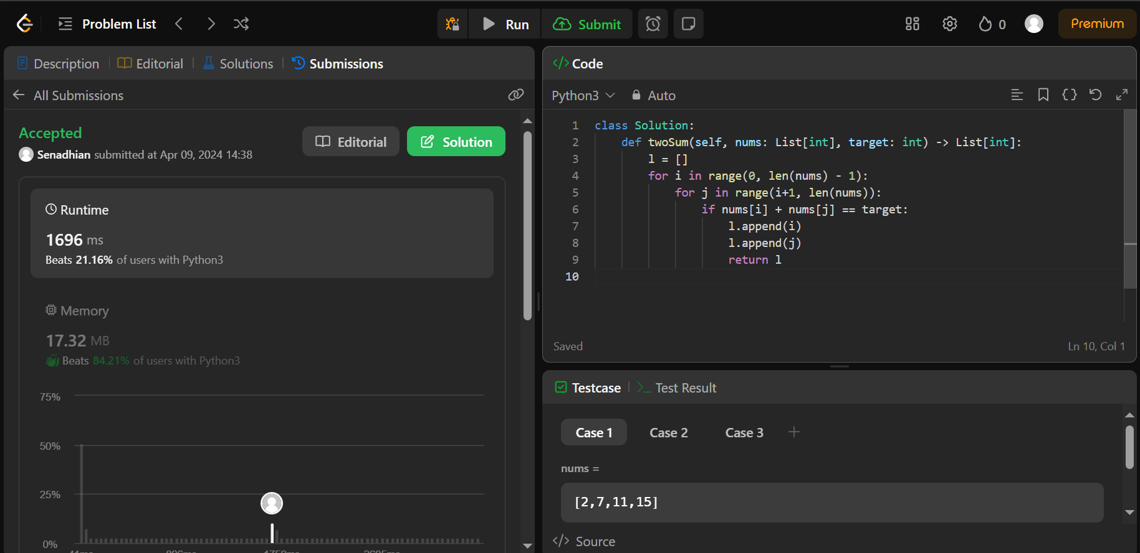

Program 2 : [Palindrome Number - LeetCode](https://leetcode.com/problems/palindrome-number/submissions/)

